MSE 609 Final Project Report – Group 11
1. Introduction
This project replicates key results from the paper “Knowledge is not all you need for comfort in use of AI in healthcare” by Li et al (2025) [1]. The original paper was published in “Public Health”, an established academic journal. The paper examined how demographic factors shape Canadians’ knowledge of AI and comfort with AI use in healthcare. Importantly, this paper found that the successful fostering of trust and integration of AI in healthcare systems may come from strong data governance, transparency, and inclusive AI design. This work is considered influential because of its timely exploration of peoples’ perception of AI in healthcare, especially as AI technology is quickly being adopted across multiple disciplines, including healthcare.
The goal of our project was to replicate key results from the original paper. We specifically chose to replicate: Table 1, which reports descriptive statistics; Appendix 1, which reports ordinal logistic regression models for four different outcomes (Q40-Q43); and Figures 1-4, which required multivariate polynomial regression. Following the replication of our targeted figures and tables, we also explored an extension beyond the original paper by examining two additional datasets of the Canadian Digital Health Survey from 2023 [3] and 2024 [4]. In this report, we detail our project process, including the data pipeline, result reproducibility, and a discussion of our replication results and subsequent extension.
2. Data
2.1 Data Source
The data for this replication was sourced from the ATS2021 Dataset from the 2021 Canadian Digital Health Survey, provided on Borealis Dataverse (N = 12,052 respondents) [2]. The dataset includes demographic characteristics, health-related behaviors, and attitudes toward AI in healthcare. All datasets, including the ones used for the extension, are accessible through the reference list and Appendix.
2.2 Variables Used
In this section, we identify and define the variables used in our replication project. Please see a full data dictionary in the Appendix.
Dependent Variables (Q40–Q43)
Our cleaned dataset included four dependent variables (Q40-Q43) representing participant’s knowledge and comfort levels with AI, measured using a four-point Likert-scale (1 = Not at all, 4 = Very):
- Q40: Knowledge of what AI is
- Q41: Comfort with AI as a tool in healthcare
- Q42: Comfort with AI research with consent
- Q43: Comfort with AI research without consent (deidentified)
Independent Variables
Our four independent variables were demographic controls that we treated as categorical factors:
- Age_new: Age group (5 different groups)
- Gender: Gender (Male, Female, Other/Non-binary)
- income (Q55): Total annual household income (7 different groups)
- education (Q66): Highest level of education completed (7 different groups)
2.3 Data Cleaning Pipeline
Our data cleaning pipeline follows the cleaning logic implied in the original paper.
- Missing values: Once we sourced our raw dataset, we treated any responses coded as a value between “96-99” as missing values or “NA” during the data cleaning process. These responses were “other” answers, or the participants did not answer or were unsure. The valid responses for the four control variables were coded as values between “1-4”.
- Data filtering: We applied two different filtering strategies during data cleaning.
  - Standard filtering: All four independent variables must have valid values. Responses coded between “96-99” (invalid responses) were removed. For the dependent variables Q40-Q43, all responses were kept. Based on this, each question provided a different sample size which matched the values in Appendix A1 of the original paper.
  - Strict filtering: Only respondents with valid responses for all eight variables (independent and dependent) were kept. Any invalid responses for Q40-Q43 were also discarded. This resulted in a sample size of n = 9,198, which is identical to the sample size of Table 1 in the original paper.
- Final samples: The final sample size we obtained after data cleaning using standard filtering was n = 10,553, which was utilized for the replications of Appendix A1 and Figures 1-4. The sample size n = 9,198 was used for the replication of Table 1 only.
We noticed a difference in the “Age” category bins in the original paper versus the dataset we used. In the original paper, the researchers organized the bins into categories like “35-54”, “55-64”, and “65+” [1]. In the dataset, we found that the bins had “35-44”, “45-54”, and “55+” [2]. These latter categories are already coded into the dataset we used for this project, and we lack sufficient information and data to alter the bins to match the categorization of the original paper.
3. Replication Results
When reviewing our replication of the 2021 dataset, we found that our results were highly similar to the original results in the paper. There were some minor differences between our replication and the original results, but we did not find any major mismatch between the trends observed in the original data and our replicated results.
3.1 Replication of Table 1
3.1.1 Data Cleaning for Table 1
- Defining Variables: We defined eight different independent and dependent variables in this replication. For Table 1, we followed the original article by only including the data for participants who answered survey questions for all of the variables.
- Data Filtering: Participants who demonstrated attrition, or had incomplete survey questions, were removed from the dataset because we did not want to replicate the results with a potentially skewed sample.
- Final Sample: This resulted in a final sample size of n = 9,198. This sample was only used for the replication of Table 1.
3.1.2 Side-by-Side Comparison
Comparing the original Table 1 against our replicated results, we determine that our replication was successful because all of the values are the same, except for the difference in the “Age” category bins that we have already discussed. Find Partial figures showcasing this in Appendix 1.
3.2 Replication of Appendix A1
The original paper’s Appendix A1 used ordinal logistic regression—specifically, the proportional odds model—to analyze Q40-Q43, which are measured by a four-point Likert scale (“1 = Not at all” - “4 = Very”) [1]. Ordinal logistic regression was used because the categories are ordered, but not evenly spaced. Our replication aimed to follow this method while using the same predictors and reference categories.
3.2.1 Data Cleaning for Appendix A1
- Defining Variables: We defined eight different independent and dependent variables in this replication.
- Data Filtering: We used the standard filtering method to clean the data, as the strict filtering method was only used for replicating Table 1.
- Final Sample: This resulted in varying sample sizes for different questions.
3.2.2 Side-by-Side Comparison
Comparing the original Appendix A1 to the replicated version, we can see that there is no significant difference between the original article and our replication. We can see a general trend among both results that older age groups demonstrate a lower comfort level with AI tools, and lower knowledge of AI [1]. Female respondents in both results also demonstrate having lower comfort levels with AI across Q41-Q43, and lower chances of being knowledgeable about AI. Additionally, our replication shows that having a higher income generally increases one’s chances of being more comfortable with AI and being accepting of data usage. This trend closely matches the results of the original paper.
When examining the p-values of the results, we did notice some minor differences, but the other metrics maintained trends similar to the original paper. For the “Odds Ratio”, neither experienced a difference in value larger than 0.4. Similarly, for the 95% confidence interval, there is no difference larger than 0.2 for the upper and lower limits. When comparing the p-value for the “25-34” Age category for the original paper, p = 0.137 [1], while the replicate p-value for the same category was p = 0.02. Similarly, for the original article’s “Apprenticeship/Trades” category bin, p = 0.935 and the replicated result is p = 0.54 [1]. The replicated Appendix A1 has successfully replicated the trend of the original. For example, the original “Education” predictor had a constantly increasing Odds Ratio until the “PhD” category, where it decreased for the following “Medical/Paramedical” category [1]. This pattern is fully replicated in our Appendix A1, and can be observed for the other categories as well.
The slight differences in the “Odds Ratio” may be explained by how the researchers cleaned the original data set versus our replication. While we tried to replicate the data cleaning methods to the best of our ability, there is a chance there may still be some discrepancies between the two results. However, the differences are slight and do not invalidate that our replication of Appendix A1 was generally successful. For partial
3.3 Replication of Figures 1-4
3.3.1 3D Surface Findings
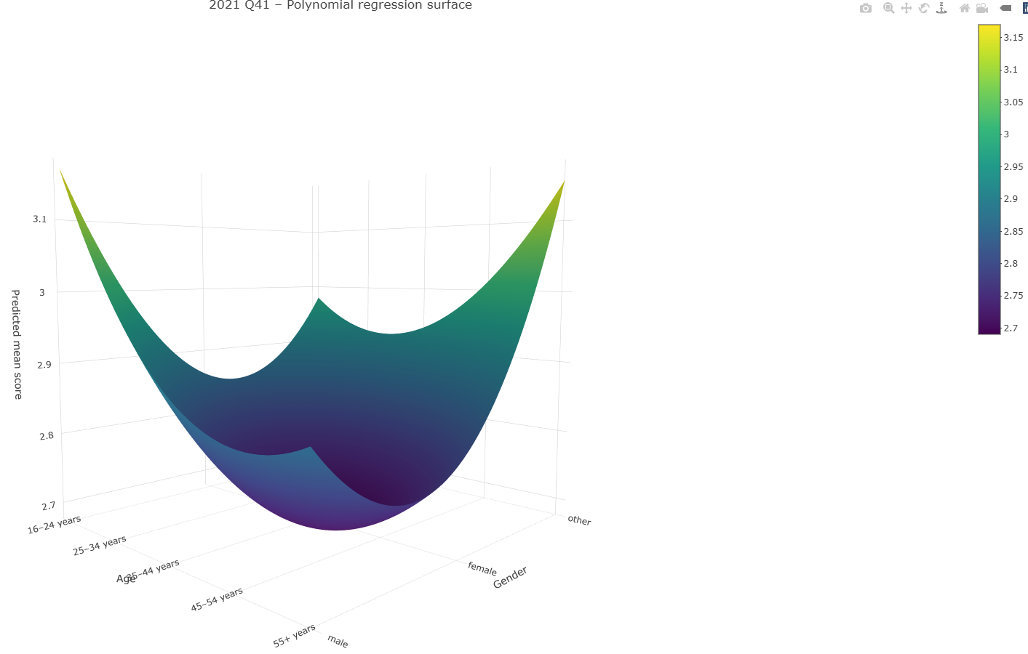
Replication of Figure 2.

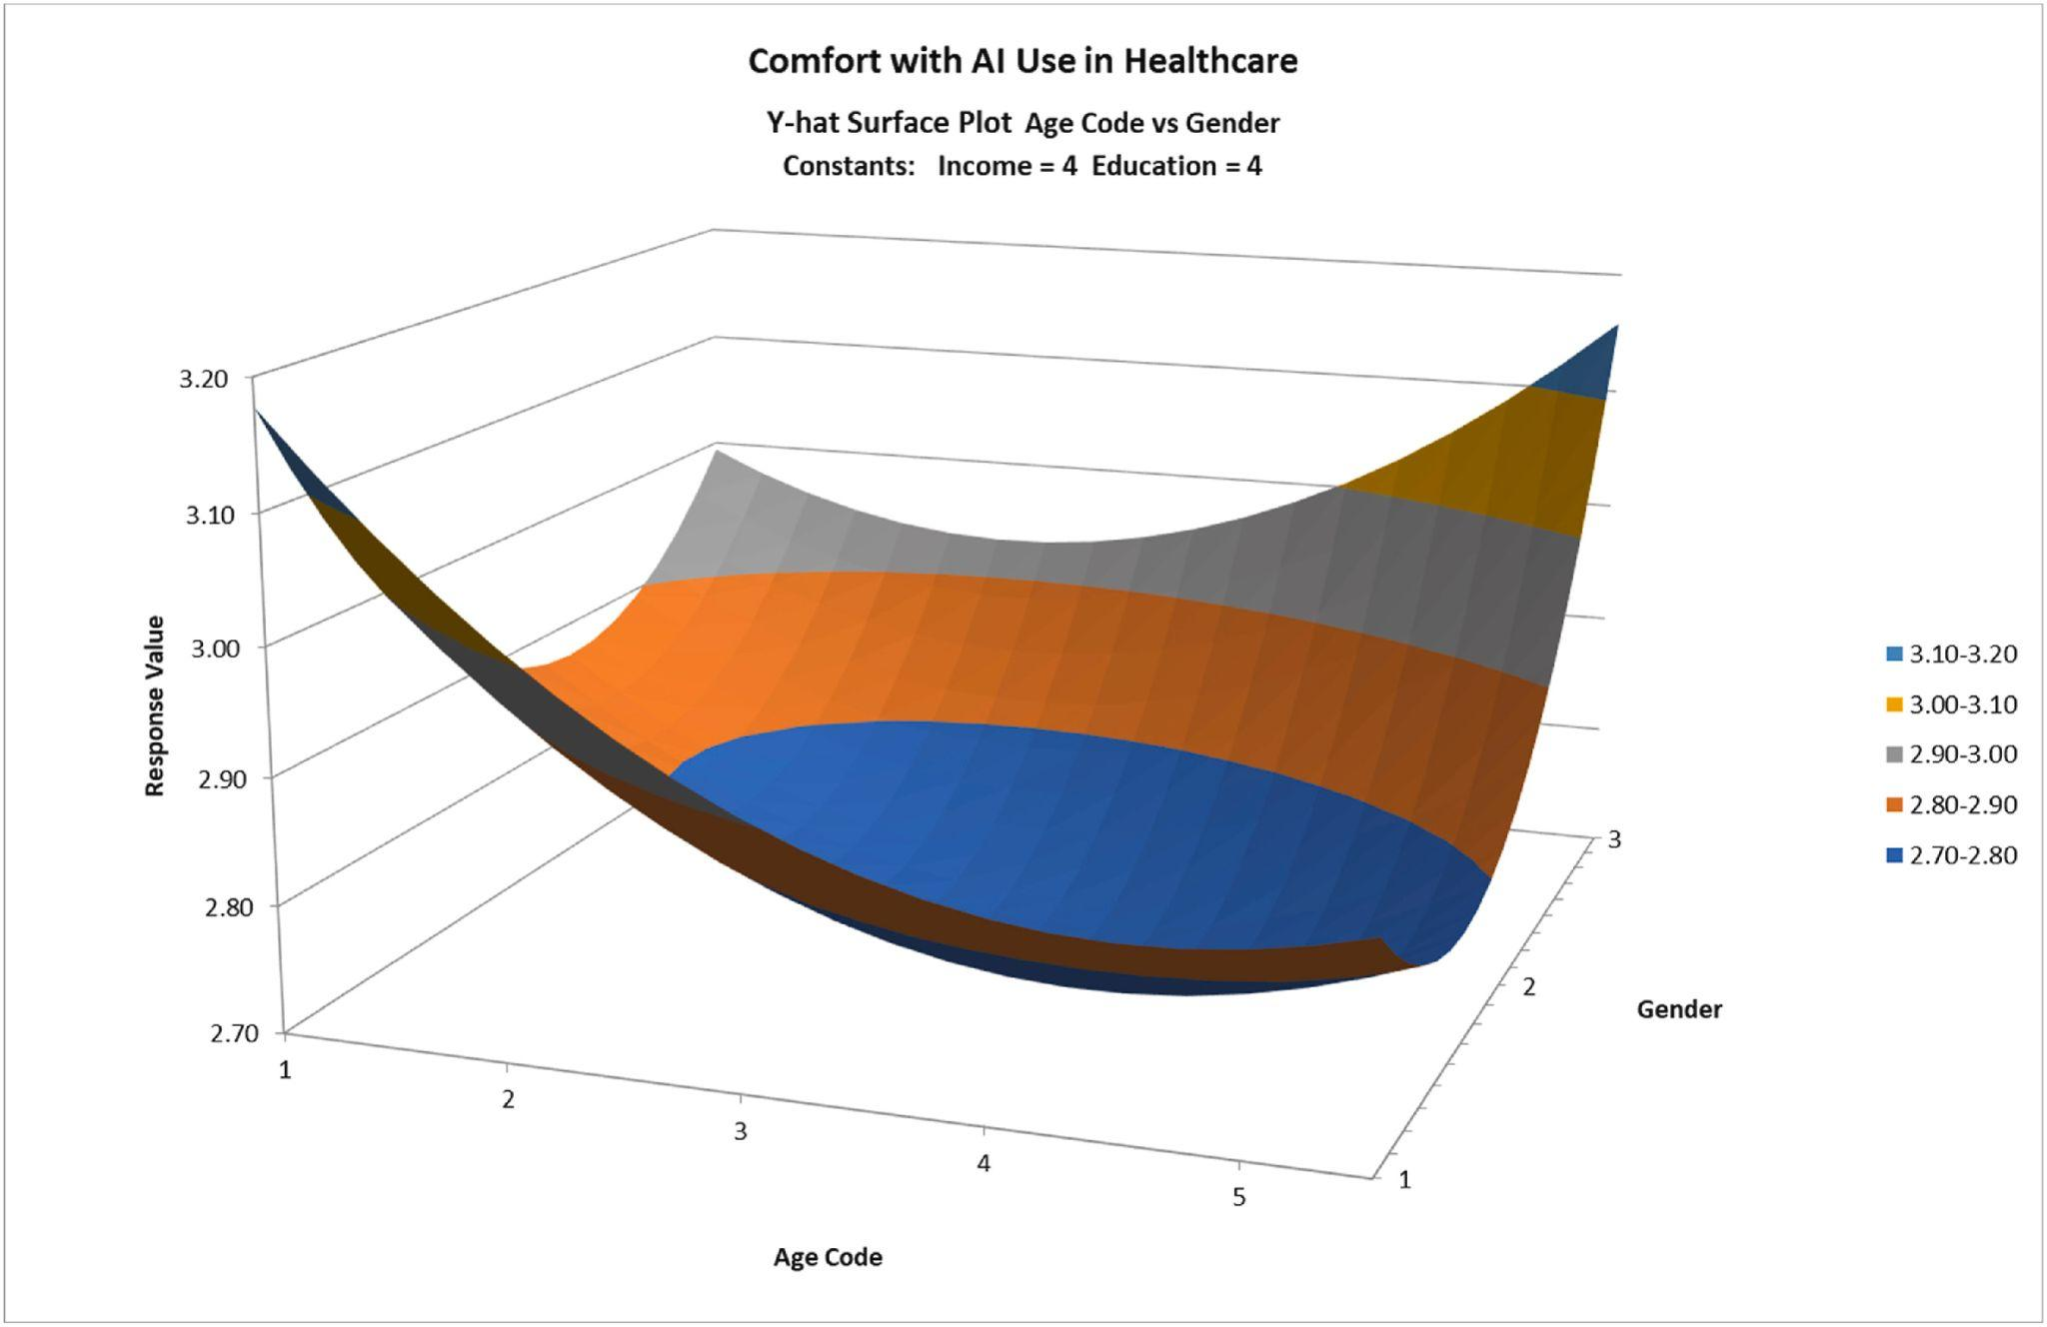
The original paper’s Figure 2 [1, Fig. 2].

Note: All findings reported below are based exclusively on respondents with university-level education and household incomes between $80,000 and $99,000.
Middle-aged and older women exhibit the lowest reported comfort with both the use of AI in healthcare and the use of their data for AI training, indicating a pronounced age–gender interaction pattern.
Across demographic groups, respondents generally report low comfort with their data being used to train AI without consent, even when de-identified. The only group that departs from this trend is males aged 16–24, who show comparatively higher comfort levels; all other groups remain at or below a comfort score of 2 out of 4.
Senior Canadians (55+ years old category) consistently display lower levels of AI knowledge and lower comfort with AI use in healthcare. At the same time, the 3D surface plots show that they report relatively higher willingness to allow their data to be used for AI training, even though their comfort with clinical AI use remains low.
In the polynomial model, most nonlinear and interaction terms do not achieve statistical significance. Only the quadratic components of age and gender emerge as meaningful contributors. This pattern is consistent with the 3D surface plots, where curvature is concentrated almost entirely along the age and gender dimensions, while the remaining variables introduce little to no nonlinear variation. As a result, incorporating additional higher-order terms into the 3D visualizations offers limited to no analytical value.
The rest of the replicated figures are accessible in the Appendix. Interpretation of 2021 is also brought up again after extension is completed for a more unified analysis.
4. Extension (New Dataset 23’ & 24’)
4.1 Purpose of Extension
We decided to explore the trend of AI knowledge across years, as we noticed that the CDHS collected further data in 2023 and 2024 with publicly accessible datasets. We examined similar research questions from the 2023 survey [3], some new information from the 2024 survey [4], and predictor variables across the years. In this extension, we paralleling stories for each year and take a look at how time, trend, and different questions may affect the analysis results. Specifically, question 31, 32, 33, 34 from CDHS 2023 are direct analogies to question 40, 41, 42, 43. Question 28_a1, 28_a3, 28_a5 are analogies to question 40, 41, 43, while the rest of 2024 question 28 provides some new questions and insights.
It is important to note that we used the same model structure and data cleaning strategies as the results we replicated from the 2021 dataset.
4.2 Analysis Result
Table 1A
The demographic patterns observed in Table 1A for 2023 and 2024 are generally consistent with the original 2021 findings. Across all years, younger respondents demonstrate greater AI knowledge and comfort, while older groups report significantly lower familiarity and trust. This generational gap widens even further in 2024. Gender differences also remain stable, with female participants consistently showing lower odds of knowledge and comfort, while the “Other” gender group shows the highest levels. Income and education gradients persist and are consistent in both 2023 and 2024, demonstrating that higher incomes may correlate with greater AI familiarity and more positive attitudes.
While there are minor numerical differences between the years, the odds ratios and confidence intervals vary only slightly, and do not greatly alter the interpretation of the results. Overall, the 2023 and 2024 results reinforce a core trend: younger, higher-income, and more educated individuals seem to be more knowledgeable and comfortable with AI in healthcare. Conversely, identifiable data consistently generates the lowest comfort levels across all groups.
3D Surface Plots
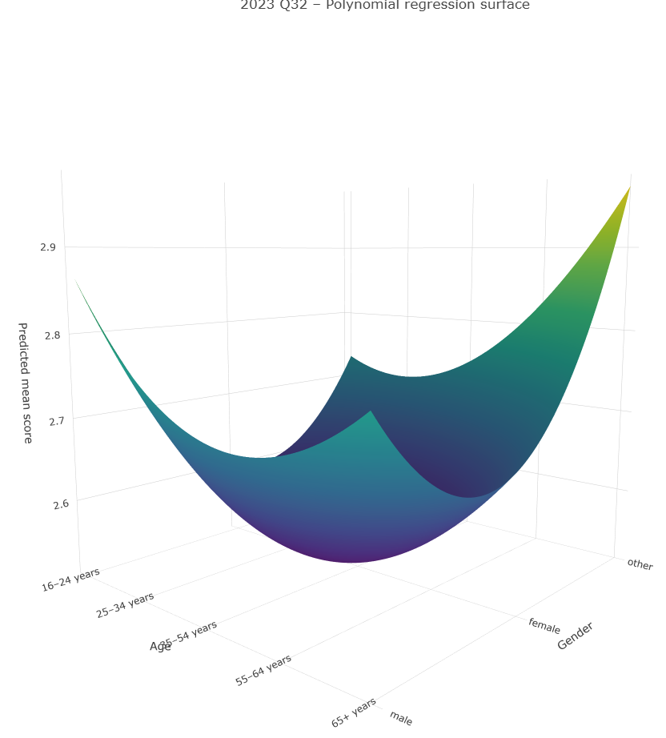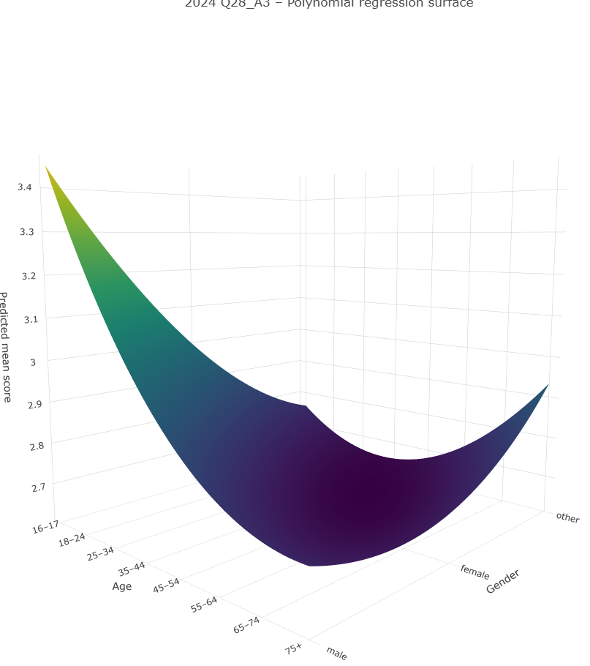
3D Surface Plot for 2023 Q32 [3]. 3D Surface Plot for 2024 Q29_A3 [4].

Knowledge about AI
In 2021, knowledge declined smoothly and consistently with age, with no midlife rebound. Knowledge steadily declined across all age groups and genders. Notably, the age slopes became slightly flatter in the older age bands, indicating a smaller knowledge difference between age groups. The “Other” gender had the highest predicted knowledge, forming the top edge of the surface. Men had moderately high values, while women had consistently the lowest predicted values, creating the depression in the surface. In 2023, the surface was still in a valley shape with the female gender group being the lowest, but the overall curvature intensity was lower than in 2021, making the surface flatter. The highest value peak was now in the young male demographic. However, in the "Other"gender group, the young "Other"reported to know less about AI compared to the older group. The surface was twisted toward higher males at the young group, with others following next and females still the lowest.
For 2024, this surface plot shows higher predicted scores overall, indicating rising public familiarity with AI knowledge. In terms of patterns, it’s more similar to 2021 than 2023. The general shape is a valley, with knowledge declining with age. Males have the highest predicted scores, followed by females. The major differences are that the curvature is significantly faltering, indicating the gap in age is decreasing as time passes. The gap between younger and older groups is also larger than in 2021, meaning that as self-reported knowledge in AI evens out, the technology generation gap widens. Younger respondents show increasingly more self-reported knowledge about AI in healthcare.
Plots can be found in Appendix 3.1, 3.5, 3.9.
Comfort with AI
For age in 2021, the surface experiences a curved U-shape relationship. Scores are highest among the youngest groups, then decline steadily through middle age, with around 35-54 being the minimum. They then rebound a bit when reaching into the 65+ groups. This suggests that youth are more confident in AI, aligning with their knowledge. Middle-aged people have the least confidence despite moderate self-reported knowledge, while the elderly regain some confidence. Gender-wise, the other gender group appears to be the highest confidence, followed by males and then females. This is consistent except for in the youngest age bracket, where young males are the highest confidence in AI holders, followed by others and then females. Because both gender and age effects are curved in a U-shape, the surface has a soft bowl in the middle, with middle-aged females being the lowest predicted confidence demographic.
In 2023 Q32, the bowl shape of the comfort curve has changed from young male to older ones. The curvature is flatter, indicating narrowing age gaps in comfort. The slope from young to old is gentler, suggesting broader distribution of comfort with AI technologies by 2023. The older other gender group has a tall ridge on the back right. Males have moderately high comfort with less dramatic peaks, while females have the lowest comfort, creating an elongated valley across the gender axis.
In 2024 Q28_A, the surface resembles a stretched-out flat plane with young males as the highest point. The older “Other” group is also elevated in the back-right. Despite middle-aged males, females, other genders, and young “Other” individuals having caught up, young males’ comfort with AI in healthcare has increased significantly. They are not more confident than in 2021 and 2023, but their comfort is relatively higher.
Plots can be found in Appendix 3.2, 3.6, 3.10.
Comfort with Identified Data with Consent
For identified data with consent, in 2021 Q42, the bowl shape is similar to 2021 Q41. Middle-aged females have the lowest comfort, while young males have the highest peak. Young others and older “Other” participants have similar high scores, and older males have moderately high scores. Young females have higher comfort, which decreases with age until middle age, and then rebounds with even older age. In 2023 Q33, the surface structure remained similar to 2021, with the lowest demographic and the highest score in “Other” older age groups. The peaks in the corners were less dramatic. We can’t conclude that these groups are less comfortable or that the middle-aged female group has reached a similar comfort level, but the gap between the center of the plot and the corners has narrowed.
Plots can be found in Appendix 3.3, 3.7.
Comfort with De-Identified Data without Consent
In 2021 Q43, young males reported the highest self-reported comfort for de-identified data without consent. This comfort decreased with age and gender. The surface had less curvature and a shallower valley compared to other surfaces of 2021.
In 2023 Q34, young males still reported the highest self-reported comfort for de-identified data without consent. While comfort decreased with age, the scores rebounded slightly for both genders, reaching 65+ years. Males had the highest score, followed by females, with “Other” being the lowest. The surface had less curvature and was even flatter than in 2021, indicating the female group rising or the “Other” group dropping.
In 2024 Q28_a5, the surface result was unusual. Older age groups dominated with high scores in all age groups, while middle-aged groups were still low and younger groups were second. Across the gender axis, males and other genders reported high predicted scores. Generally, males had the highest score, but the difference was not large. The age difference was smoother and more monotonic, with less gap in age.
Plots can be found in Appendix 3.4, 3.8,3.11.
New questions in 2024
Knowledge about AI use in healthcare (2024 q28_a2): This question is similar to our core question but focuses on healthcare. When reformed, self-reported scores decrease in most groups except for young males. Trust in unbiased AI (2024 q28_a4) reports that young and older people trust AI more than middle-aged people. Young males are still the most trusting, but young females also report moderately high predicted scores, more than “Other” participants, even in older age groups. Female predicted scores exceed those of males and “Other” participants. Surprisingly, both young and old people of all genders reported high privacy concerns for AI (2024 q28_a7), despite their generally positive attitudes toward AI and healthcare AI usage in previous questions. Young males and males in general had the lowest privacy concerns, while females were in the middle.
Plots can be found in Appendix 3.12 - 3.15.
Cross-Year Synthesis
Across all three years, several demographic patterns remained stable: women consistently reported lower AI knowledge and comfort than other two gender groups. “Other” gender and young male respondents generally reported the highest scores. Middle-aged adults repeatedly showed the lowest comfort across all measures and the strongest reservations about data use. Higher education and income were reliable predictors of greater AI knowledge and comfort and lower privacy concerns. Over time, surfaces became progressively flatter, indicating shrinking gender differences and more uniform comfort levels across age groups. However, the generational divide in AI familiarity widened dramatically by 2024, as younger respondents increasingly reported much higher AI knowledge than older adults. A notable shift in 2024 was the rise of seniors as the highest-comfort group for de-identified data use, suggesting that increased exposure to healthcare and digital systems may be altering attitudes among older Canadians. Taken together, the three years point to a population that is gradually normalizing AI in healthcare while maintaining persistent concerns about privacy and fairness, especially among middle-aged adults and specific gender groups.
5. Reflection
5.1 What We Learned About Data and Filtering
Replicating the paper required careful attention to how data was cleaned and filtered. We learned that very small changes in how we cleaned our data could directly impact the sample size and interpretation of our data. The data cleaning process helped us understand the importance of using various strategies to generate a clean, high-quality dataset. In turn, this ensured we would have better accuracy and reliability in our insights, made analysis more efficient because we were eliminating issues in the initial stages of our replication, and helped with a more successful replication of the original paper’s results.
5.2 Lessons About Modeling and Reference Categories
When working with categorical predictor variables, we learned that reference categories are very important for analysis and interpretation of our results. For instance, if the baseline of age, gender, or income changed, it would completely shift the results, odds ratios, and interpretation of the data after analysis. By replicating the original paper, we had to ensure we were keeping the predictor baseline the same for each of the following variables: age, gender, income, and education so that our results would be reproducible.
5.3 Reproducibility Challenges
Throughout this report, we discussed several gaps and challenges in reproducibility. Minor discrepancies in our replication of the original paper stemmed from various factors. While we attempted to replicate the data cleaning methods described in the original paper, slight process variations, including human error, may have occurred. We observed a discrepancy in the “Age” categorical groupings between the raw data and the dataset we used, which we could not fully match. This may mean that the authors processed the raw data differently than we did, which was not fully clarified.
Despite these challenges, our replication was generally successful, and we observed many of the same trends as the original data. The minor differences did not negatively impact our results. Our key takeaway from this project is that while data replication demands successful reproducibility, it also emphasizes transparency in research, open-source data access, and attention to detail.
5.4 Limitations
This study relies on CDHS self-reported data, which are vulnerable to recall and social-desirability biases. Because responses cannot be independently verified, the validity and reliability of key measures remain uncertain, limiting the precision of any inferences drawn from them.
Although the 2021 and 2023 waves use identical wording, the 2024 survey modifies several survey questions, creating potential measurement non-equivalence. Note that even subtle changes in phrasing can shift how respondents interpret the question, reducing comparability across years.
The response format also changed: 2021 and 2023 used a 1–4 Likert scale with no midpoint, while 2024 used a 1–5 scale that permits neutral answers. This structural change alters response distributions and may introduce artificial differences in comfort or attitudes when comparing trends over time.
6. Reproducibility Appendix
In the Appendix, we have included all the relevant information documenting the reproducibility of our work. This includes the data dictionary, the exact commands to reproduce our figures, software information, a file tree, and the data usage information.

References
- A. K. C. Li, I. A. Rauf, and K. Keshavjee, “Knowledge is not all you need for comfort in use of AI in healthcare,” Public Health, vol. 238, pp. 254–259, Jan. 2025, doi: 10.1016/j.puhe.2024.11.019.
- Canada Health Infoway, “2021 Canadian Digital Health Survey.” Borealis, 2021. doi: 10.5683/SP3/CEYG42.
- Canada Health Infoway, “2023 Canadian Digital Health Survey.” Borealis, 2024. doi: 10.5683/SP3/5C7HSO.
- Canada Health Infoway, “2024 Canadian Digital Health Survey.” Borealis, 2025. doi: 10.5683/SP3/MI0HZP.
Appendix
Teamwork and Division of Work
Our group worked together across different roles to successfully replicate the targeted results of the original paper and report our findings. The entire group contributed to brainstorming which paper we would use for replication. Gary, Kai and Agam focused on data acquisition once we had finalized a paper, and the entire group also searched for ways to access datasets and sources.
For Phase 2, the entire group participated in regular meetings and check-ins, and we did our best to coordinate schedules to do so. Gary, Kai, Aymen, Leila, and Agam explored data cleaning, regression models, and plots. The entire group helped with documentation of the process and project planning. Zayn took the lead on writing the final report, and Leila, Agam, and Zayn made contributions to the final presentation. The entire group made edits and contributions to the final report to ensure alignment on the content and accuracy of our report. We worked together to divide work efficiently, communicate across technical and non-technical aspects of the project, and play to our individual strengths throughout the project.
AI Use Declaration
AI tools (ChatGPT, GPT-5.1, Gemini 3) were used to support prose editing, formatting, summarization, file organization throughout this report, adhering to the project guidelines. The written content of this report came from our project group, and referencing our project’s GitHub repository for additional clarification. The core statistical analyses, data cleaning, regression modeling, and code execution were performed by the authors, and assisted by AI via vibe coding.
File Structure

MSE609-Group11-Project/
├── R/
│ ├── 00_project_setup.R
│ ├── 01_data_cleaning.R
│ ├── 02_descriptives_table1.R
│ ├── 03_ordinal_logistic_regression.R
│ ├── 04_plots_Q40_to_Q43.R
│ ├── 05_different_dataset.R
│ ├── 06_plots_different_dataset.R
│ └── 07_extension_tables.R
│ └── utils/
│ └── common_utils.R
│
├── data/
│ └── data_raw/ # Raw 2021 / 2023 / 2024 files
│ └── readme.md # Instructions of getting the original dataset
│
├── artifacts/
│ ├── tables/ # Table 1 and other tabular outputs
│ ├── plots/ # 3D figures and visualizations
│ └── models/ # Regression outputs
│
├── docs/
│ └── examples/ # Example Plot
│ └── q40_2021.png
│
├── renv/ # renv environment library
├── renv.lock # Locked package versions
├── run_all.R # Main pipeline executor
├── MSE609-Group11-Project.Rproj
└── README.md

Exact Commands to Reproduce

1. Clone the Repository
git clone https://github.com/CorelessXeon/MSE609-Group11-Project.git
cd MSE609-Group11-Project

2. Restore the R Environment
renv::restore()
3. Run the Full Pipeline
source("run_all.R")
run_all.R will execute scripts 00 through 07 in sequence. It will take 3-7 minutes (depending on the PC hardware).

Data Usage Note
The data used in this project come from the Canadian Digital Health Survey (CDHS) datasets provided by Canada Health Infoway and hosted on Borealis, the Canadian Dataverse Repository, under the University of Victoria Dataverse Collection.
Access to the datasets requires acceptance of Infoway’s Custom Dataset Terms, which restrict usage to educational and research purposes within Canada. Redistribution, publication, or sharing of the datasets is not permitted.
Only anonymized, non-identifiable microdata were accessed, and all analyses comply with Infoway’s restrictions on re-identification and disclosure of personal information. Raw datasets are not included in this document and must be obtained directly from Borealis under the applicable license.
Data Dictionary

Independent Variables
Variable | Type | Values | Description
age_new | Ordered factor | 1=16–24, 2=25–34, 3=35–44, 4=45–54, 5=55+ | Respondent age group
gender | Factor | 1=Male, 2=Female, 3=Other | Self-reported gender
Q55 | Ordered factor | 1–7 (income brackets) | Household income (before tax)
Q66 | Ordered factor | 1–7 (education levels) | Highest education completed
Dependent Variables
Each is a 4-level Likert scale:
Variable | Type | Values | Meaning
Q40 | Ordered factor | 1=Not at all knowledgeable  2=Not very knowledgeable  3=Moderately knowledgeable  4=Very knowledgeable | Knowledge about AI
Q41 | Ordered factor | 1=Very uncomfortable  2=Moderately uncomfortable  3=Moderately comfortable  4=Very comfortable | Comfort with AI as a healthcare tool
Q42 | Ordered factor | 1=Very uncomfortable  2=Moderately uncomfortable  3=Moderately comfortable  4=Very comfortable | Comfort with AI research with consent
Q43 | Ordered factor | 1=Very uncomfortable  2=Moderately uncomfortable  3=Moderately comfortable  4=Very comfortable | Comfort with AI research without consent (deidentified)
Missing Value Coding
Raw Code | Meaning | Treatment
96 | Other (specify) | NA
97–98 | Prefer not / Refused | NA
99 | Don’t know | NA

Strict Dataset Definition
A secondary cleaned dataset (cleaned_dataset_strict.rds) was produced to replicate the strict inclusion protocol used in the original ATS study.
Strict filtering rule:
Any respondent with NA in any of the dependent variables (Q40–Q43) was removed.
As a result:
- Final strict analytic sample size = 9,198 respondents
- This strict dataset is used only for descriptive statistics (Table 1) and associated visualization
- All regression models and 3D plots use the non-strict cleaned dataset (cleaned_dataset.rds)
Summary of Variable Usage Across Scripts
Script | Dataset Used | Variables Used | Purpose
01_data_cleaning.R | raw → cleaned_dataset.rds | All input variables | General cleaning, recoding
02_descriptives_table1.R | cleaned_dataset_strict.rds | IVs + DVs | Strict filtering + Table 1
03_ordinal_logistic_regression.R | cleaned_dataset.rds | IVs + DVs | Ordinal logistic models
04_plots_Q40_to_Q43.R | cleaned_dataset.rds | IVs + DVs | 3D response surface plots
05_different_dataset.R | raw 2023/24 → cleaned | All 2023/24 fields | Cleaning new datasets
06_plots_different_dataset.R | cleaned 2023/24 | IVs + DVs | 3D plots for 2023/2024

Table & Plots

- Table 1
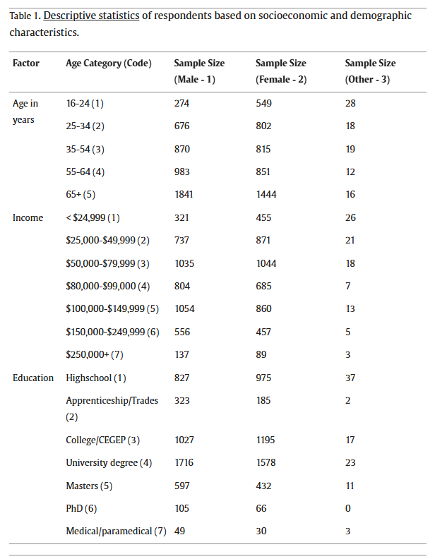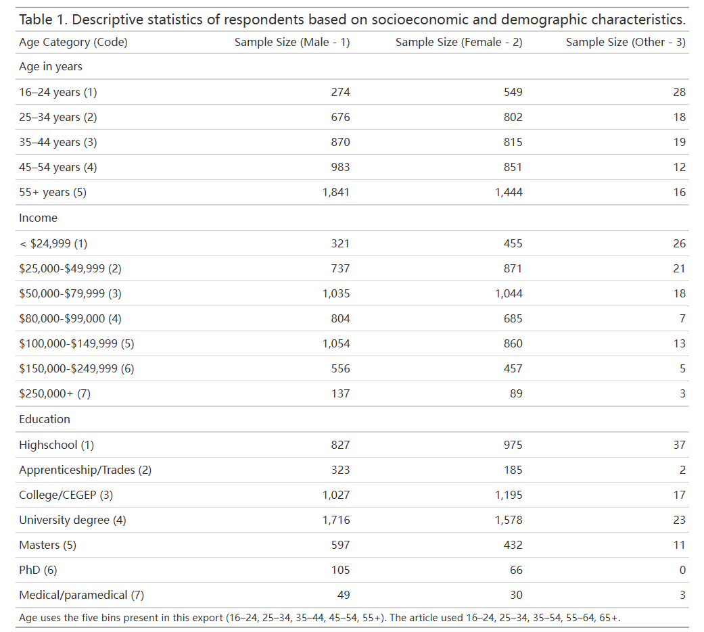
The original paper’s Table 1 (left) and our replication of Table 1 (right).
- Appendix Table 1A
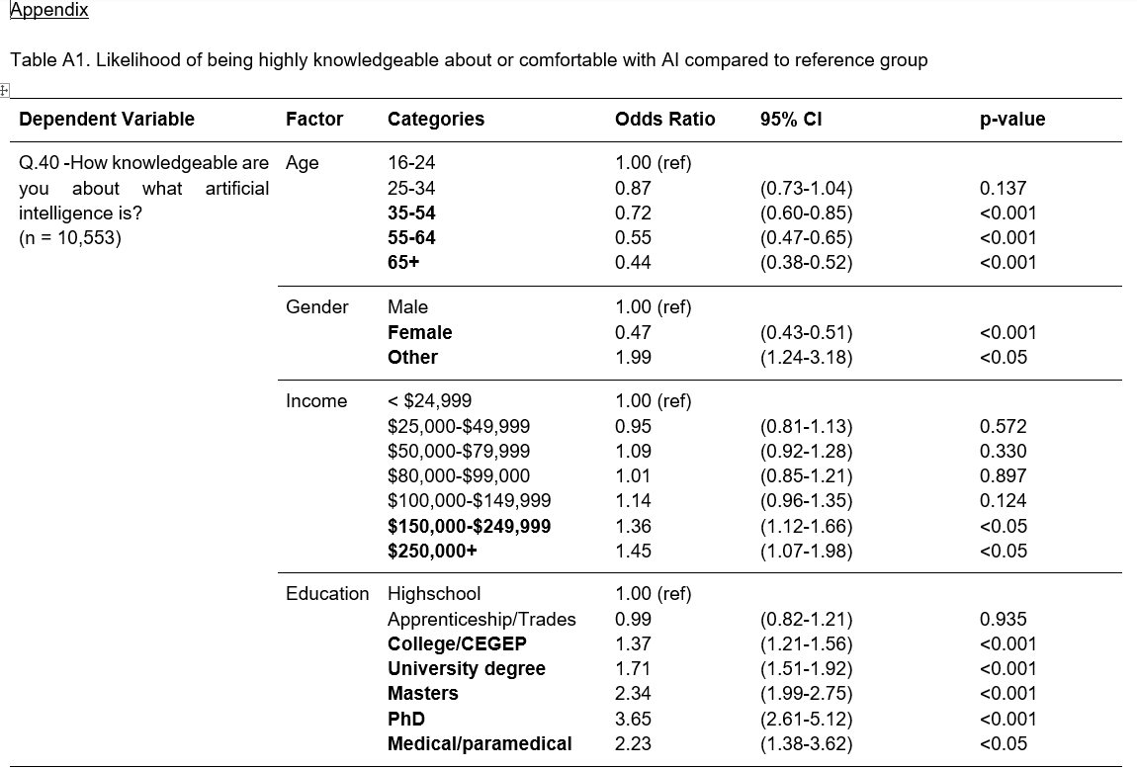
The original paper’s Appendix A1.
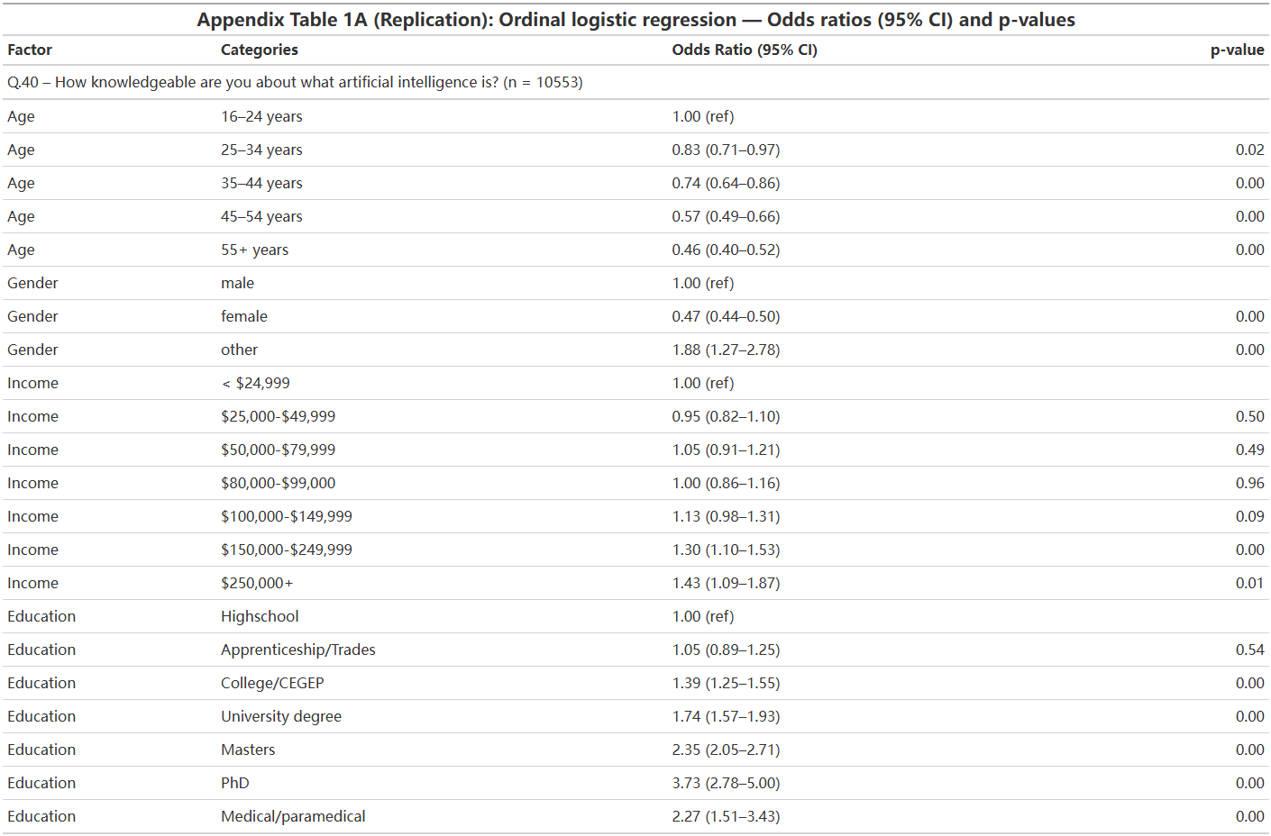
Our replication of Appendix A1.

- 3D Surface Plots
  - 2021 Q40 On a scale of 1-4 with 1 being not at all knowledgeable and 4 being very knowledgeable: How knowledgeable are you about what artificial intelligence is?
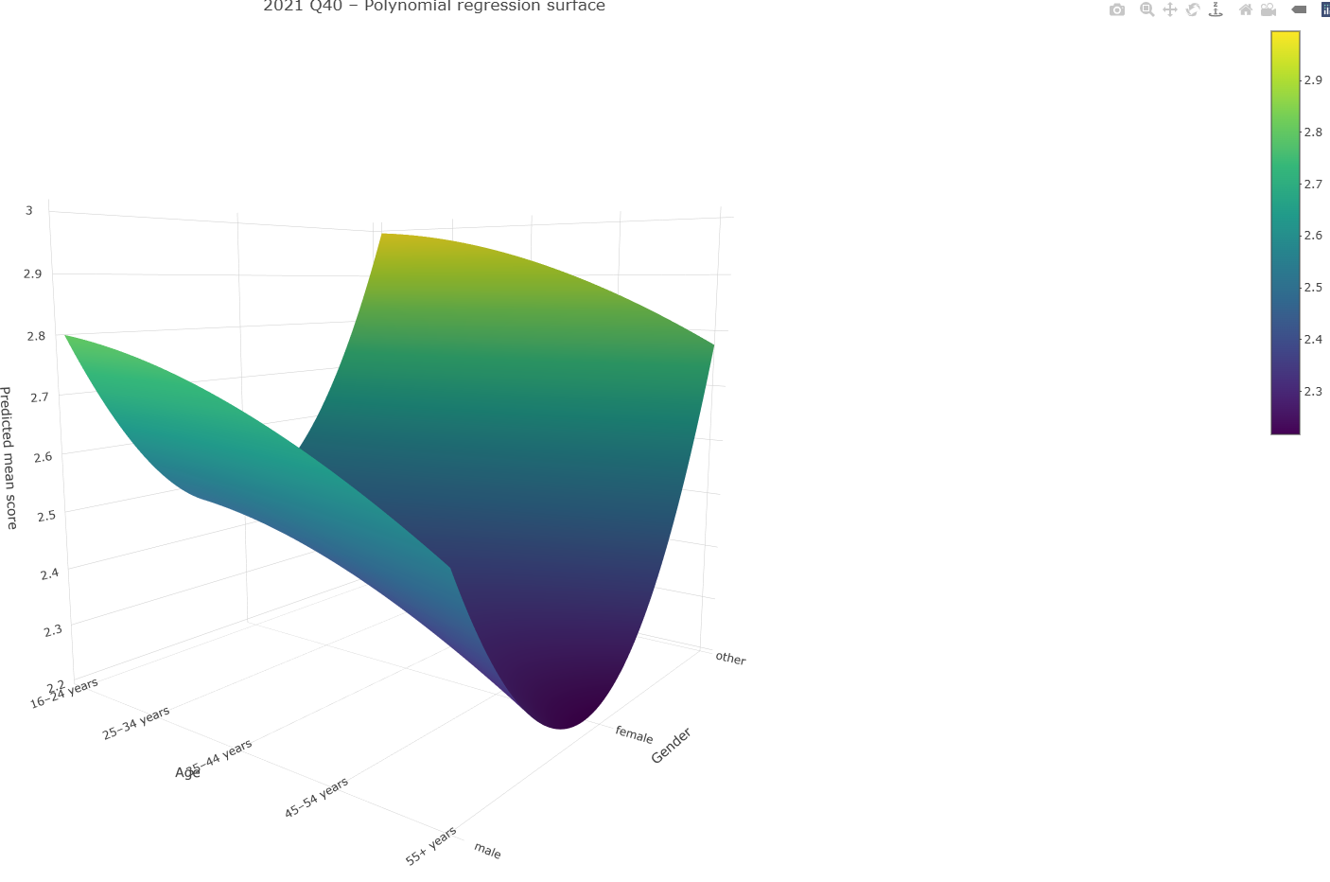

  - 2021 Q41 On a scale of 1-4 with 1 being very uncomfortable and 4 being very comfortable: AI has major potential when used in healthcare because it can rapidly process vast amounts of information. How comfortable are you with AI being used as a tool in healthcare?
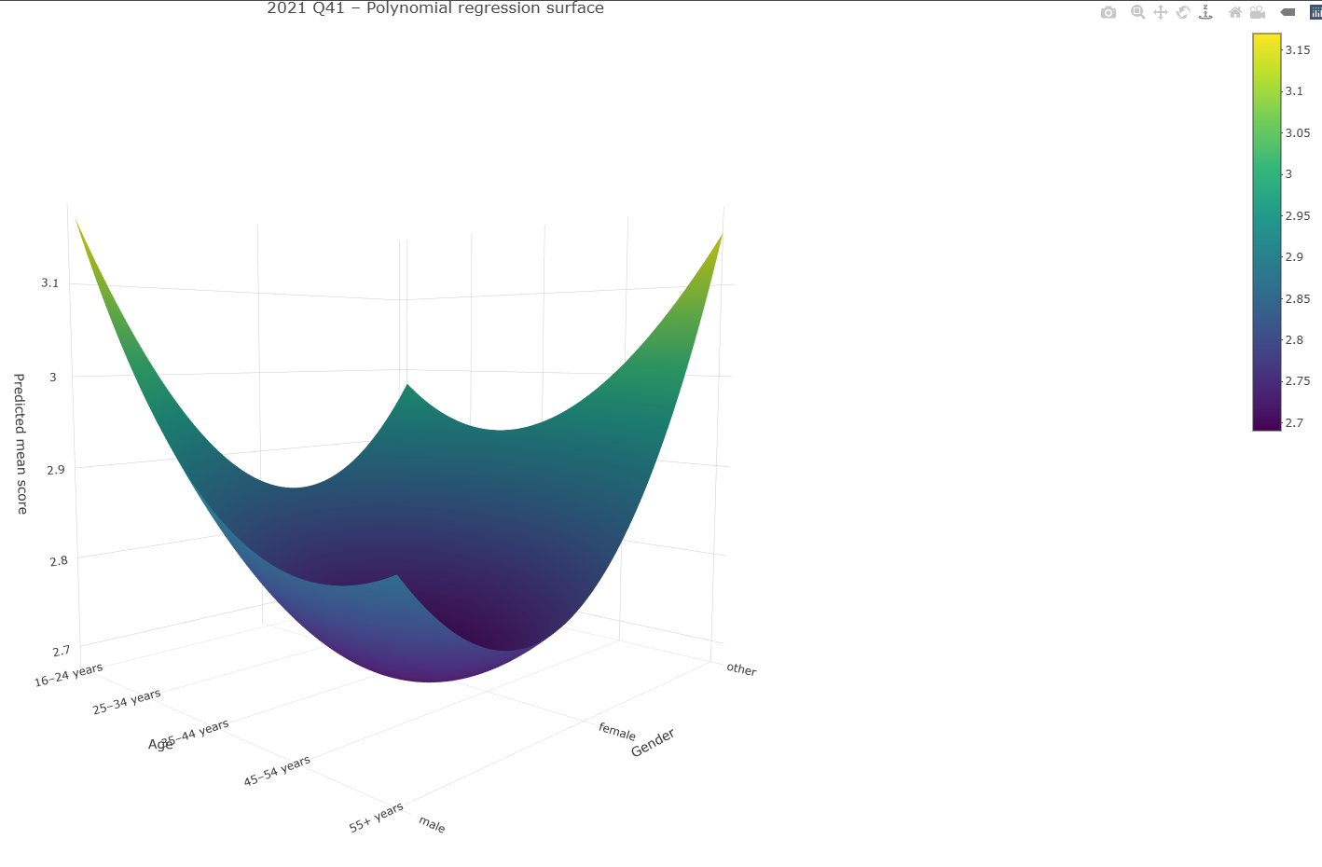
  - 2021 Q42 How comfortable are you with scientists using personal health data for AI research as long as informed consent has been provided by the patient?
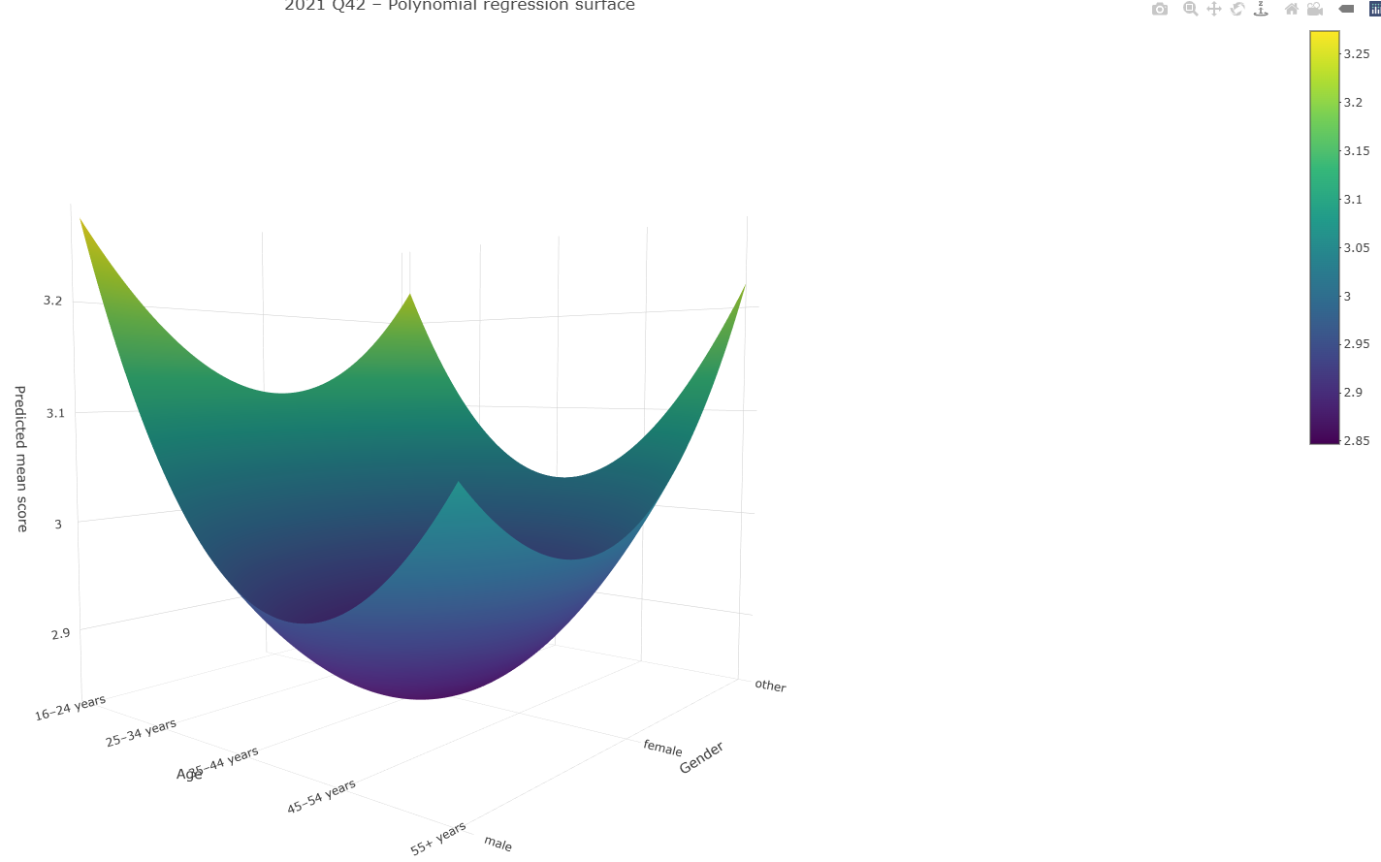
  - 2021 Q43 How comfortable are you with scientists using personal health data for AI research without informed consent as long as it is deidentified (i.e., personal information such as name, date of birth has been removed)?
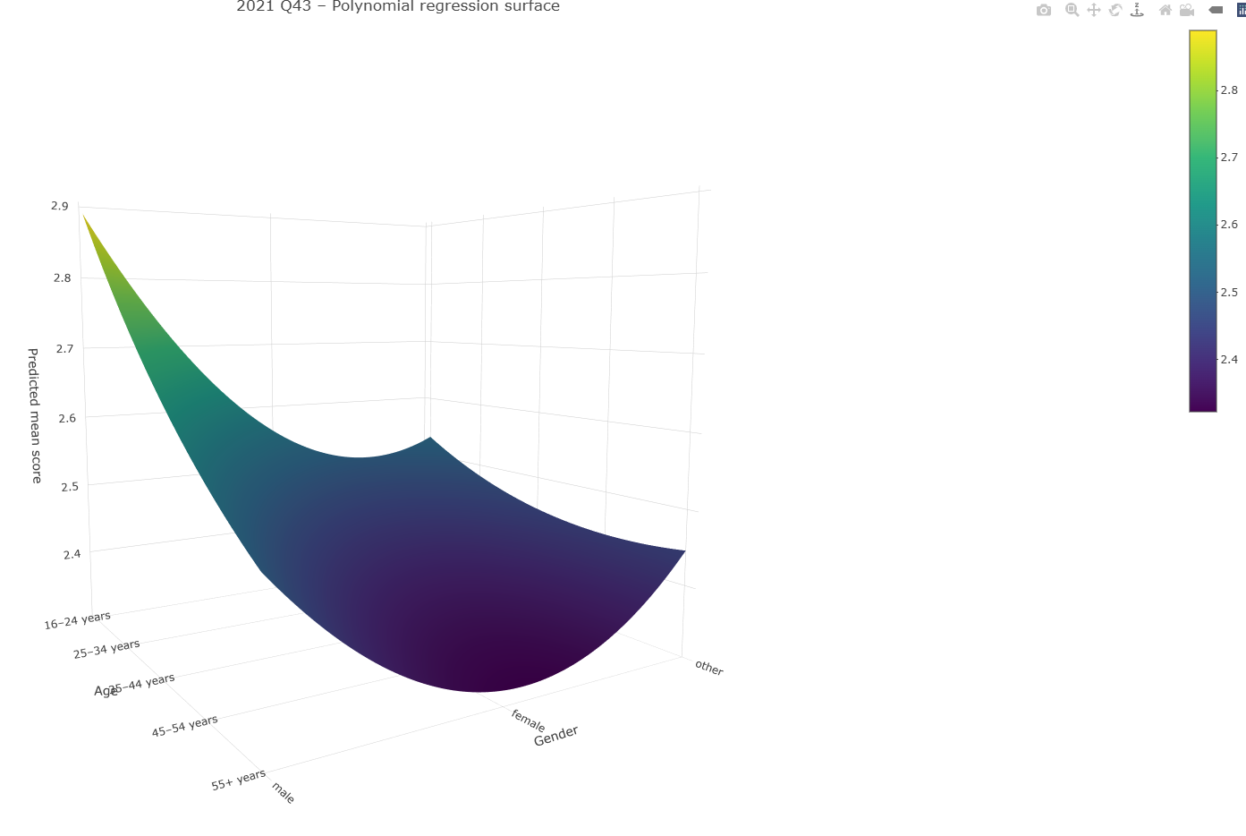
  - 2023 Q31 On a scale of 1-4 with 1 being not at all knowledgeable and 4 being very knowledgeable: How knowledgeable are you about what artificial intelligence is?
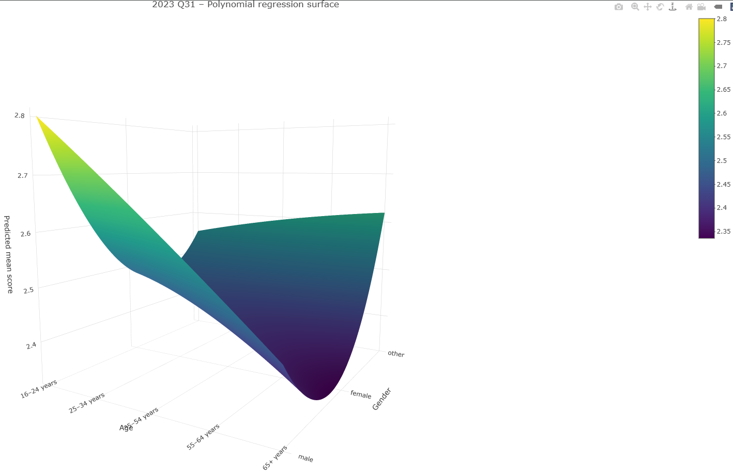
  - 2023 Q32 On a scale of 1-4 with 1 being very uncomfortable and 4 being very comfortable: AI has major potential when used in healthcare because it can rapidly process vast amounts of information. How comfortable are you with AI being used as a tool in healthcare?
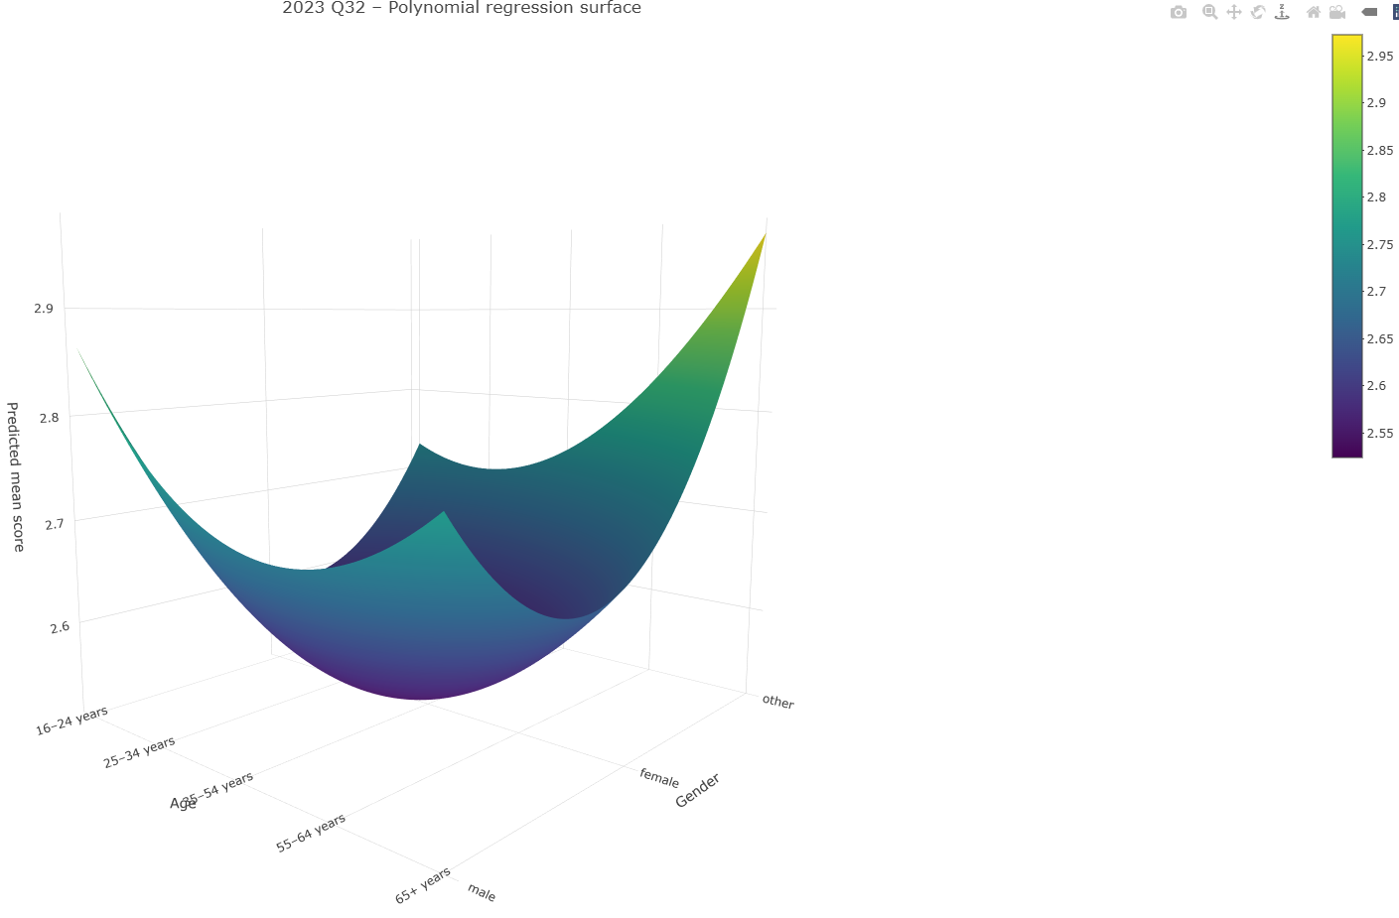
  - 2023 Q33 How comfortable are you with scientists using personal health data for AI research as long as informed consent has been provided by the patient?
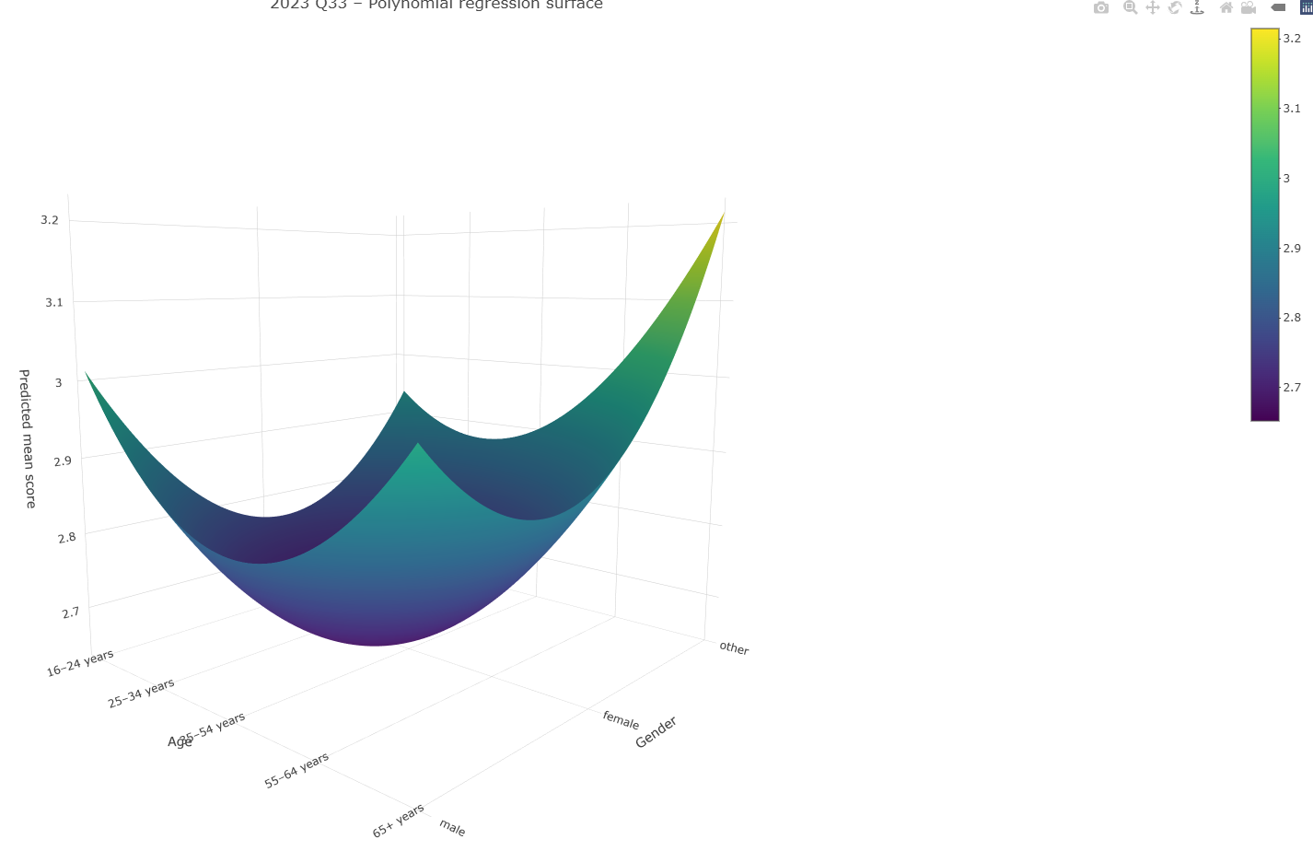
  - 2023 Q34 How comfortable are you with scientists using personal health data for AI research without informed consent as long as it is deidentified (i.e., personal information such as name, date of birth has been removed)?
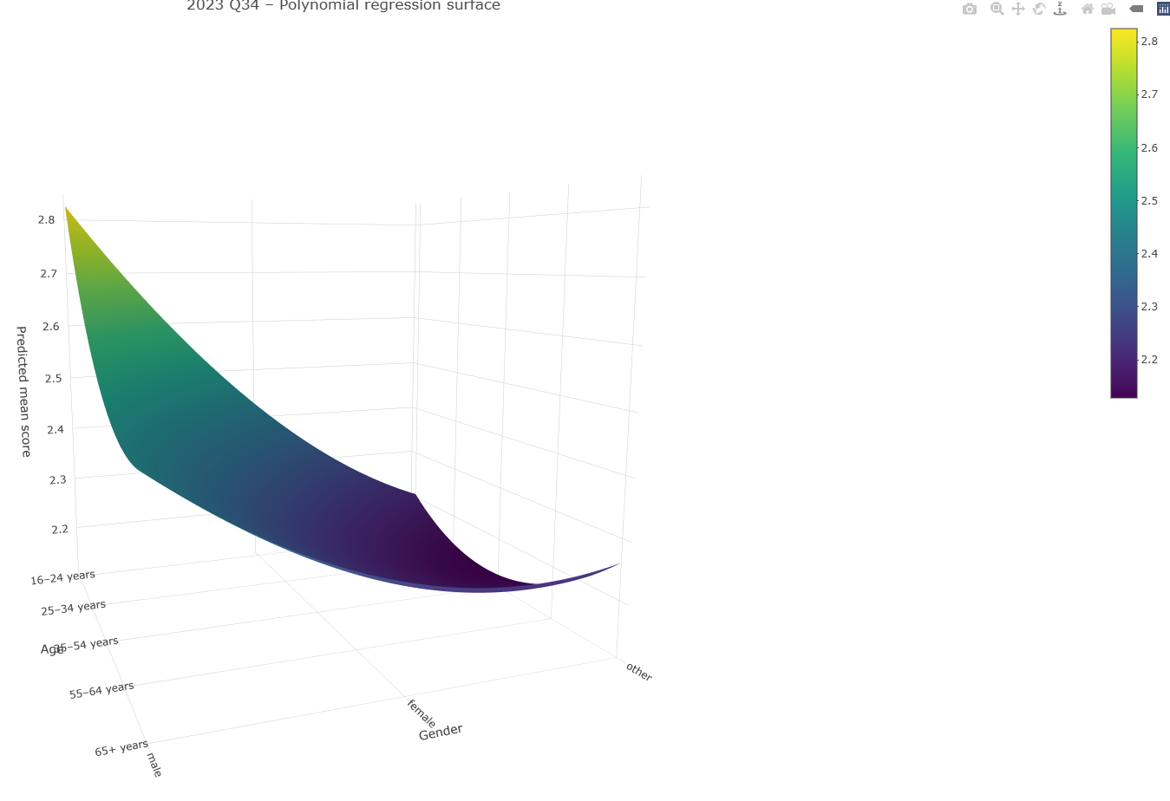
  - 2024 Q28_A1 I am knowledgeable about what artificial intelligence (AI) does.
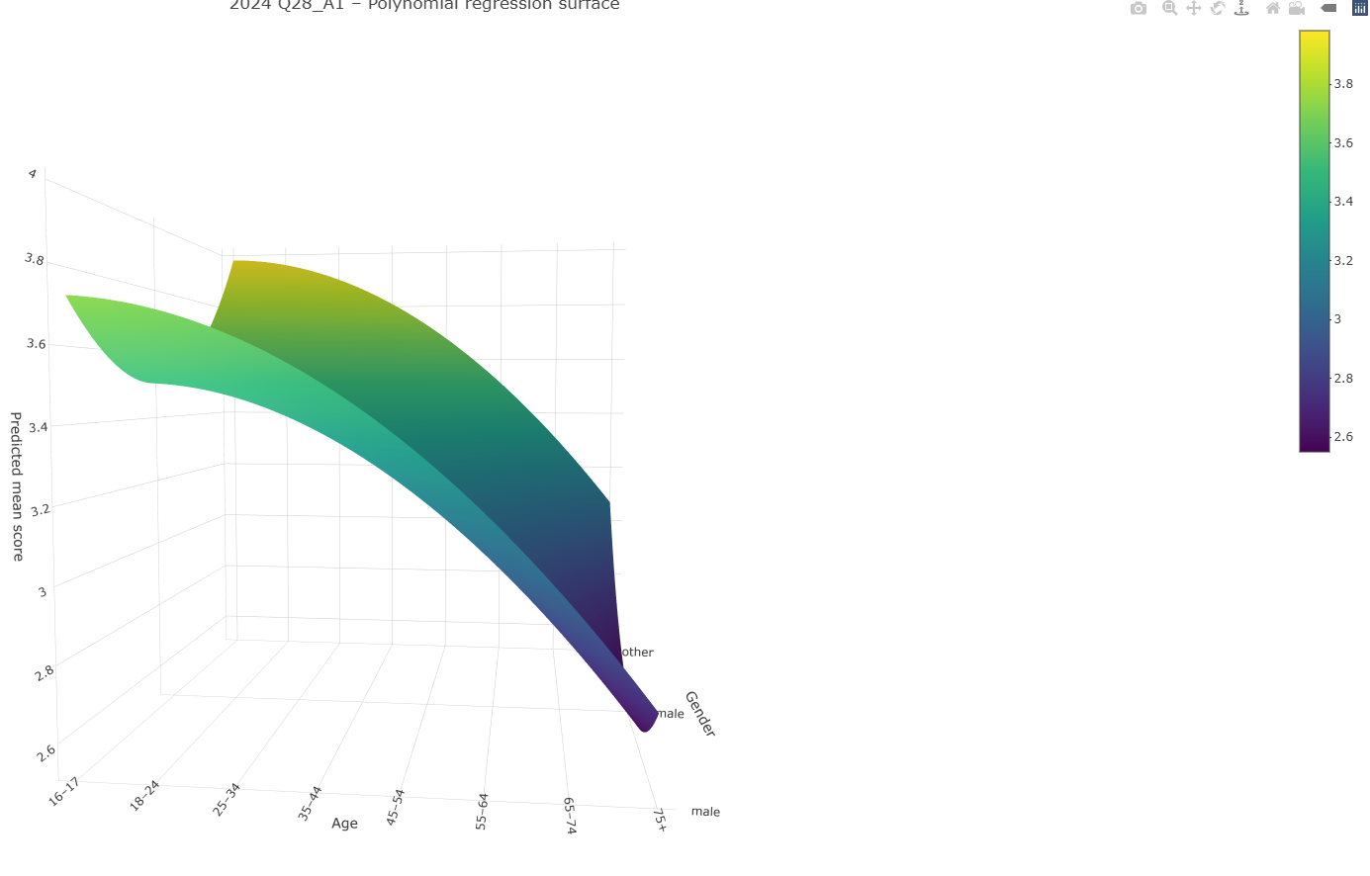
  - 2024 Q28_A3 I am comfortable with AI being used in health care.
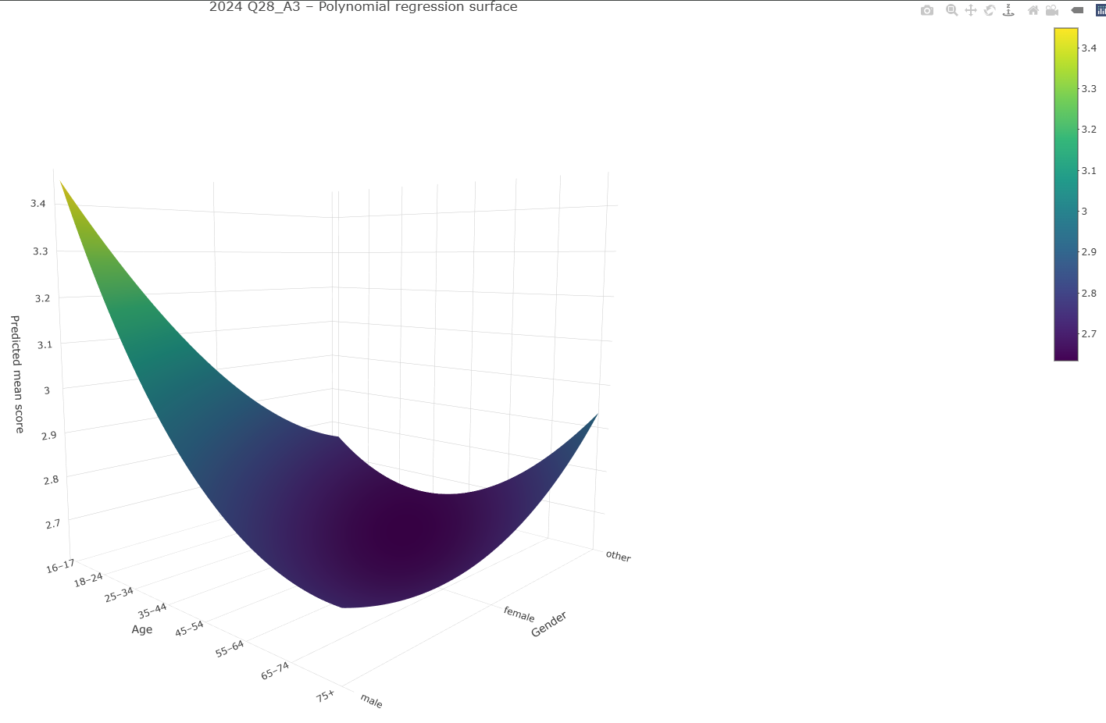
  - 2024 Q28_A5 Scientists can use my health data for AI research as long as it is de-identified (i.e., personal information such as name, date of birth has been removed).
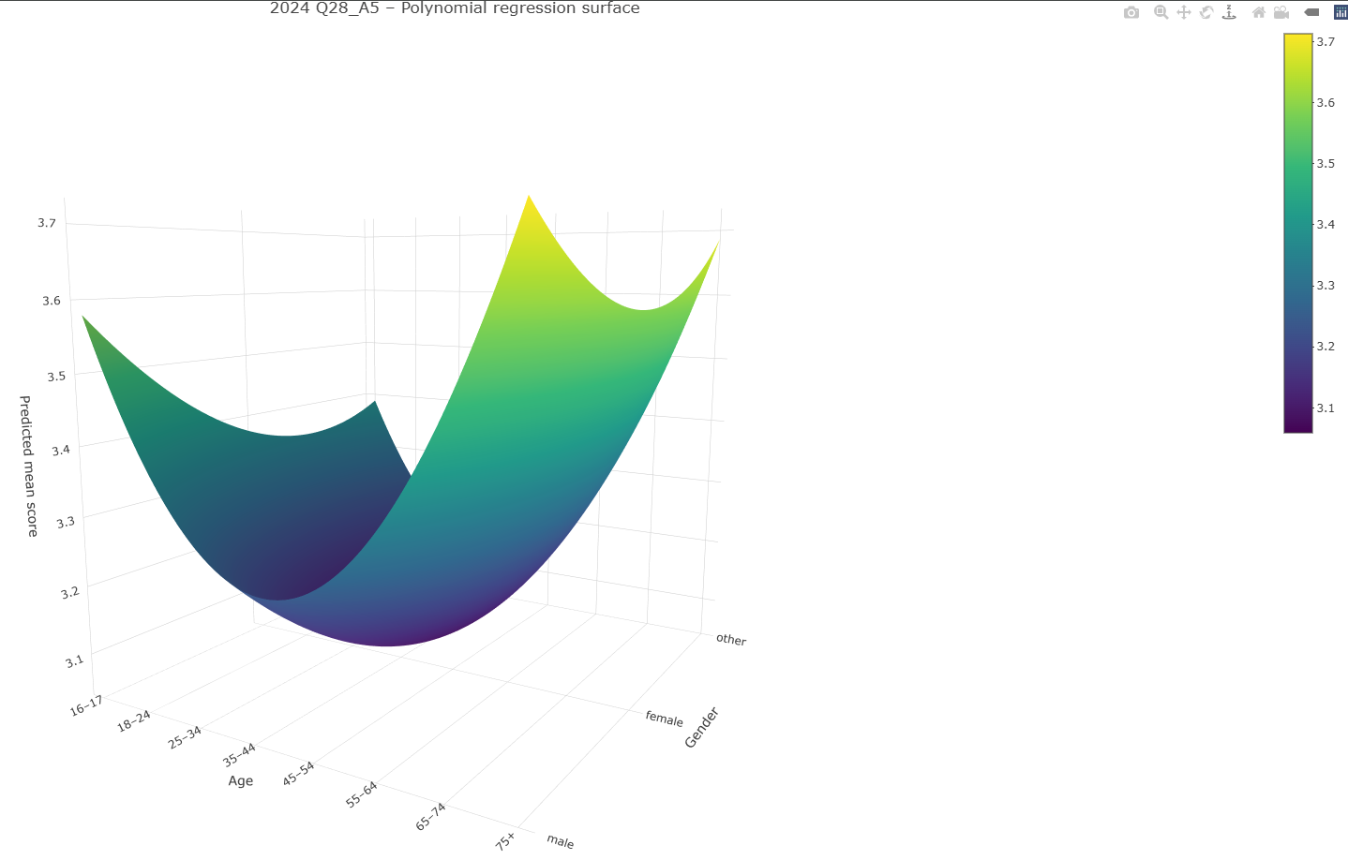
  - 2024 Q28_A2 I am knowledgeable about how AI is used in health care.
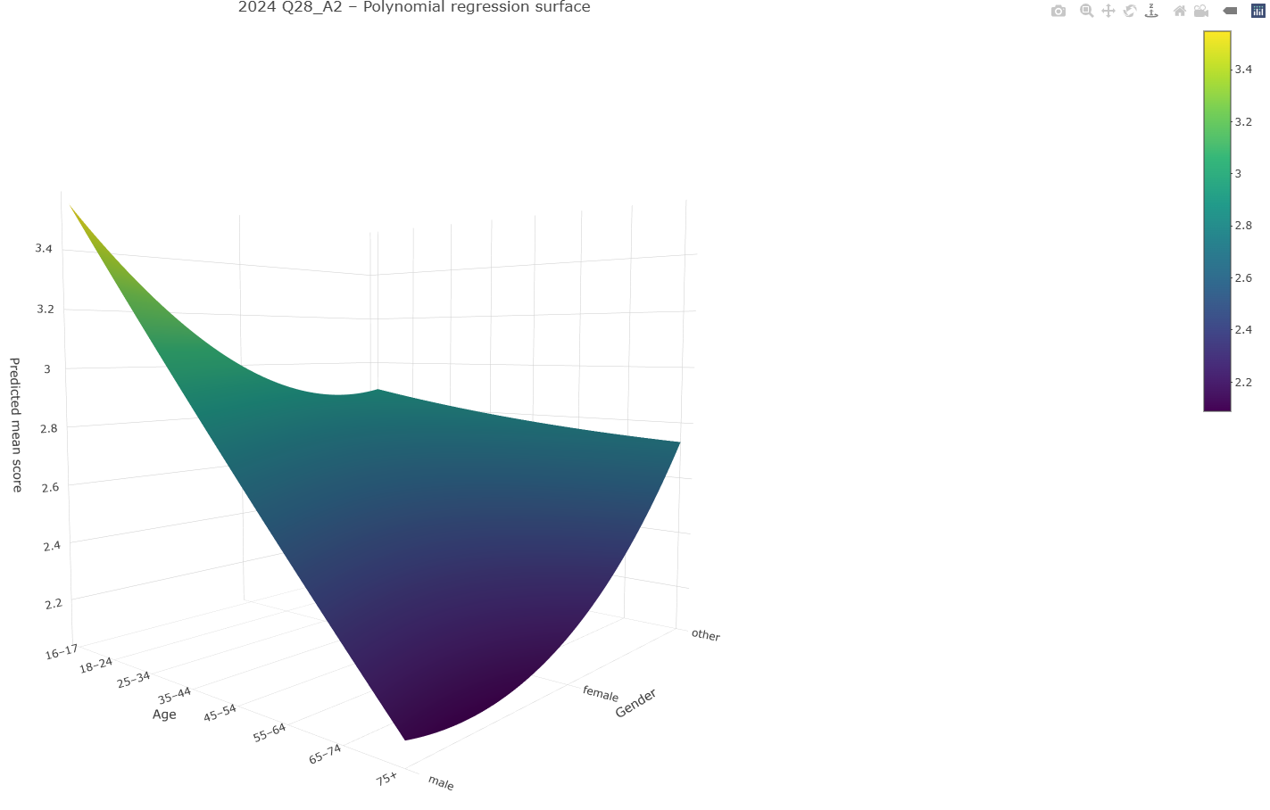
  - 2024 Q28_A4 I trust AI to be unbiased when used in health care.
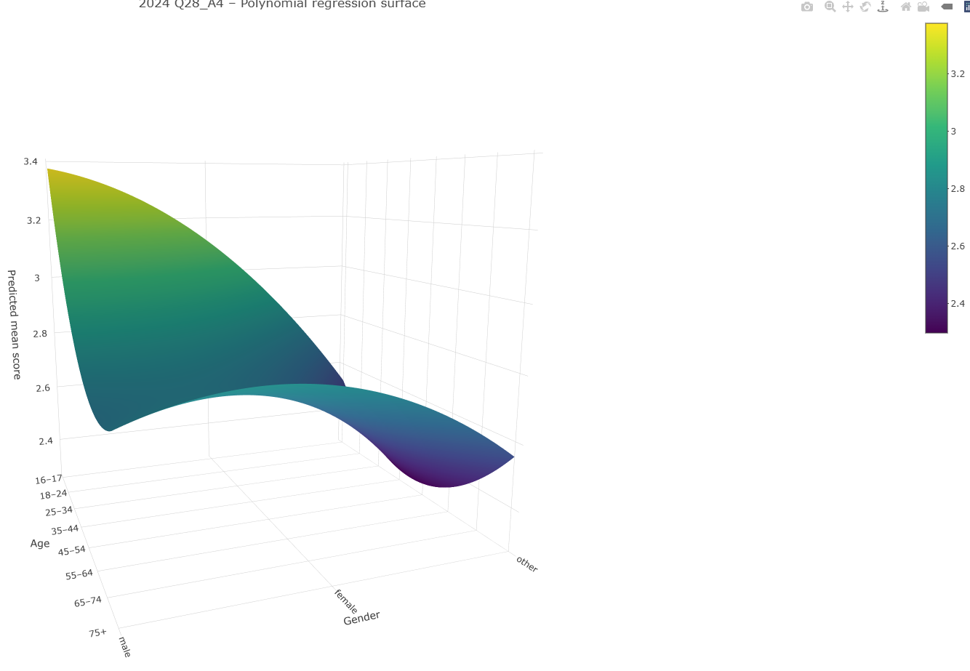
  - 2024 Q28_A6 The use of AI by health care providers improves my confidence in my disease diagnosis.
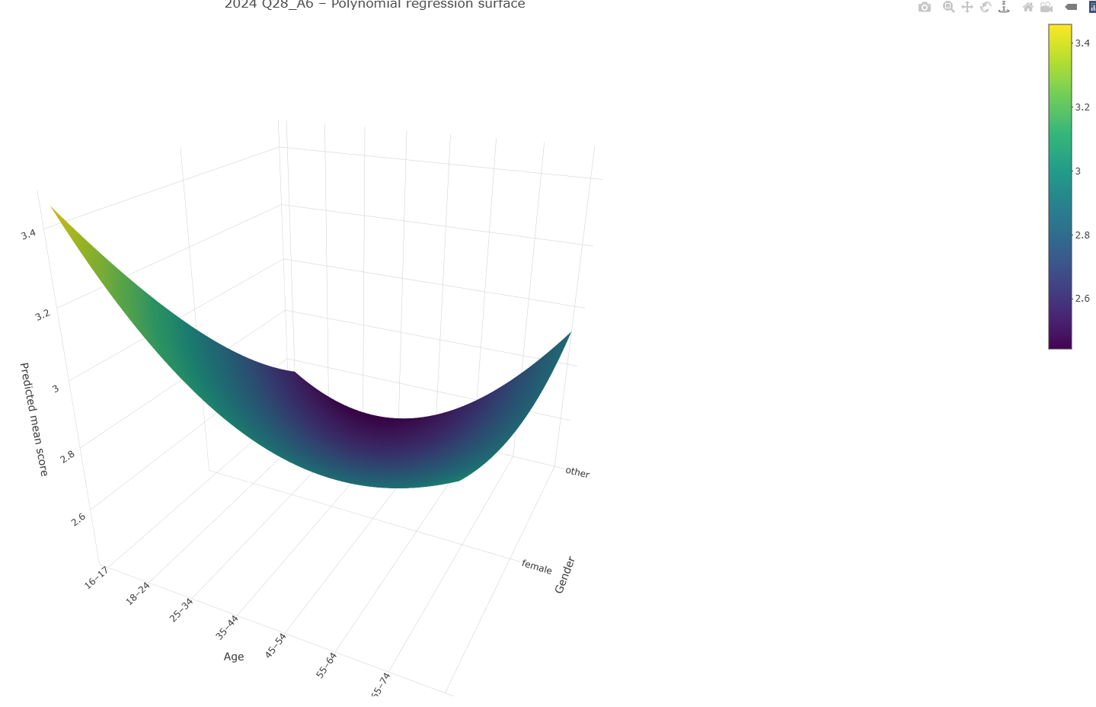
  - 2024 Q28_A7 I have privacy concerns regarding AI use in health care.
